1. 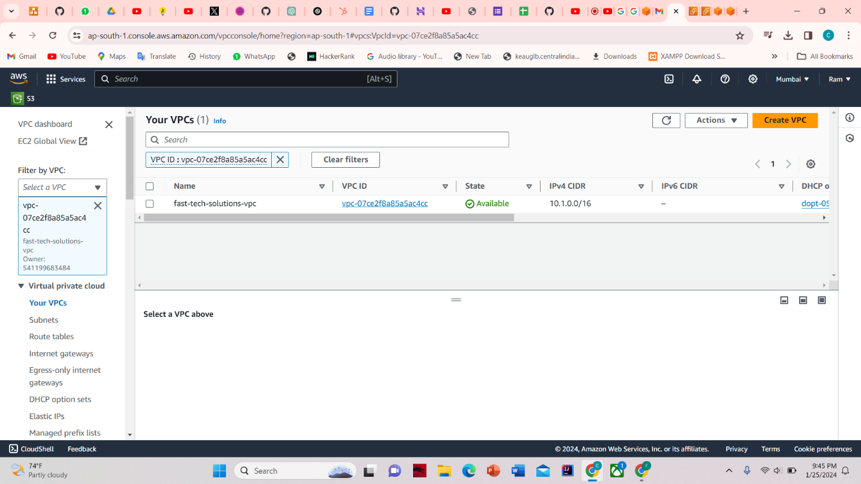VPC

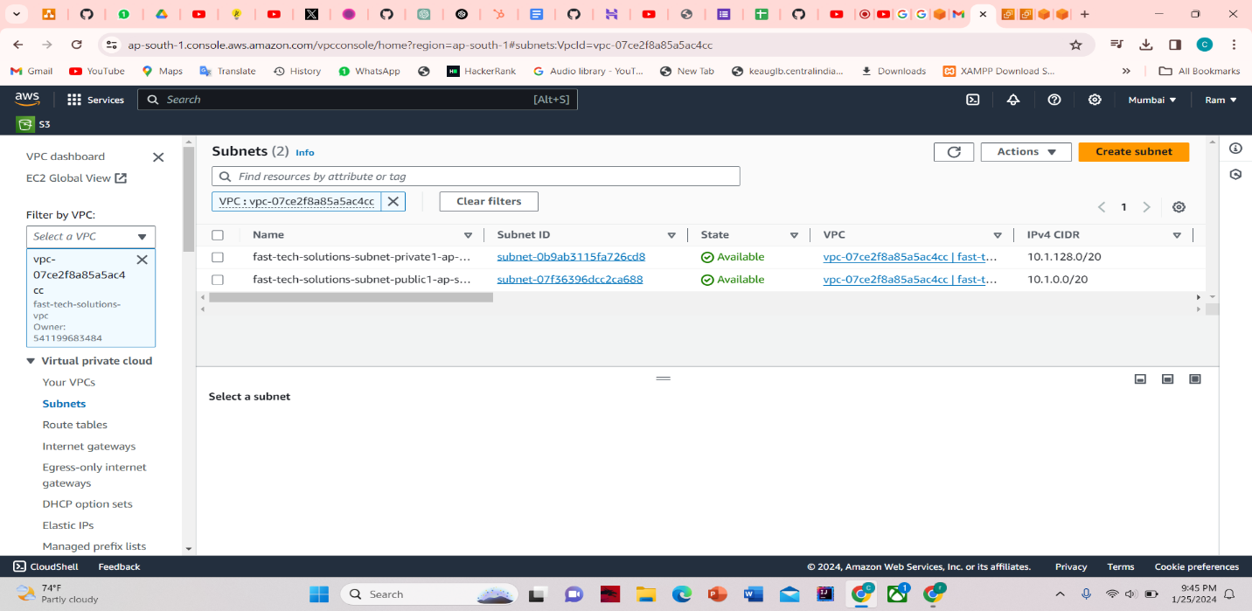

1. SUBNETS

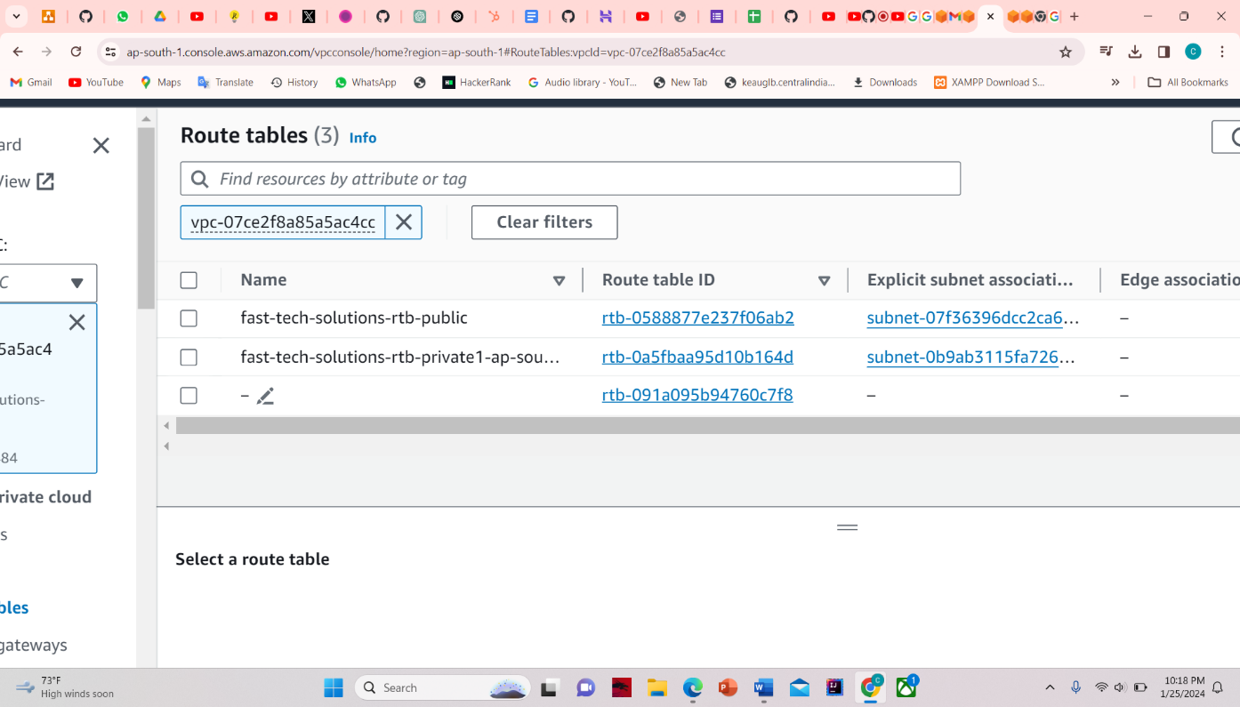

3.Route table

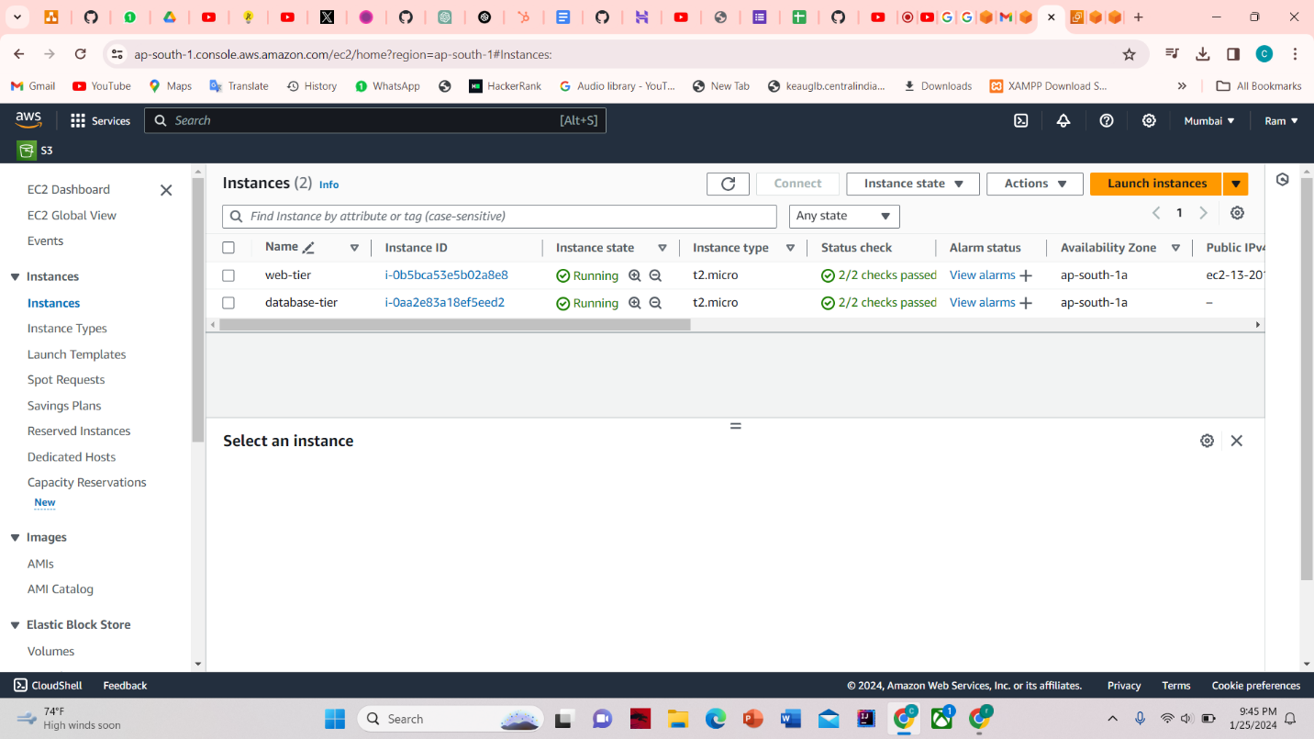

4.EC2

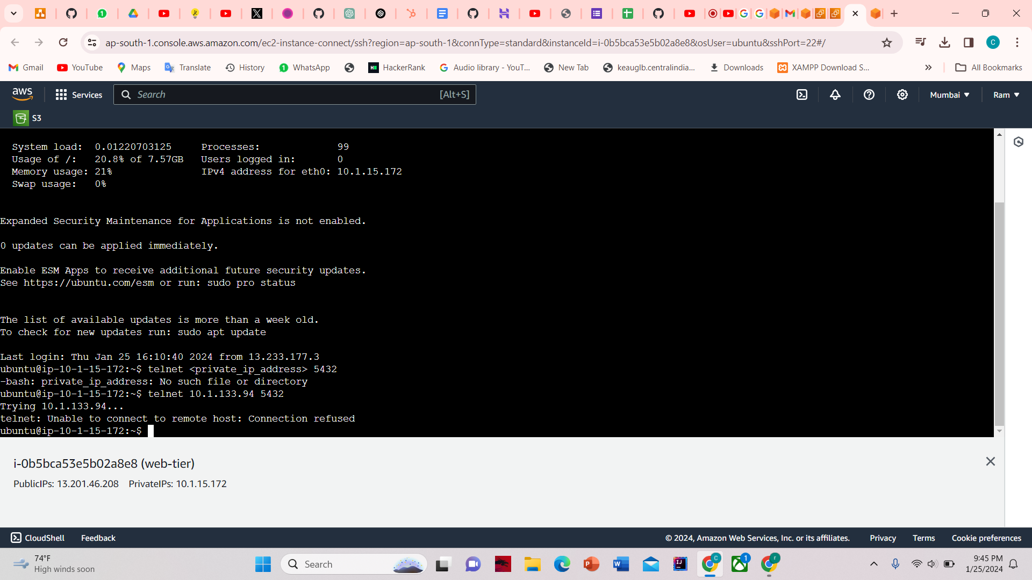

5. SSH to web-tier EC2 instance and try to connect to database-tier using telnet. Syntax below

telnet 10.1.133.94 5432